Problem 1

Query 1:
SELECT W_Location_D.Location_Id,
Location,
W_Sales_Class_D.Sales_Class_Id,
Sales_Class_DESC,
Base_Price,
Time_Year,
Time_Month,
SUM ( QUANTITY_ORDERED ) AS Sum_Job_Qty,
SUM ( QUANTITY_ORDERED * Unit_Price ) AS Sum_Job_Amount
FROM W_JOB_F, W_Location_D, W_TIME_D, W_Sales_Class_D
WHERE W_Location_D.Location_ID = W_Job_F.Location_Id
AND W_JOB_F.CONTRACT_DATE = W_TIME_D.Time_ID
AND W_Job_F.Sales_Class_Id = W_Sales_Class_D.Sales_Class_Id
GROUP BY W_Location_D.Location_Id, Location_Name,
W_Sales_Class_D.Sales_Class_Id, Sales_Class_Desc,
Base_Price, Time_Year, Time_Month;

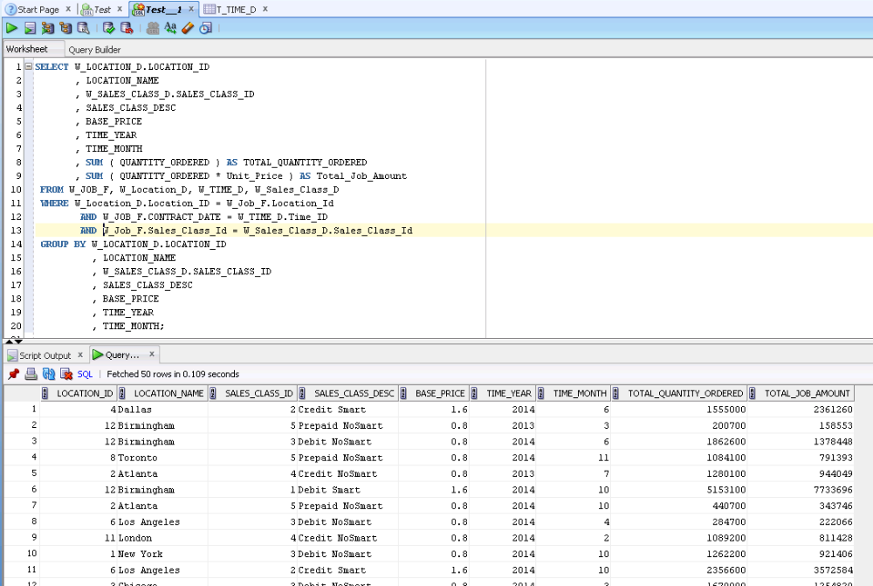

Query 2:
SELECT W_Sub_Job_F.Job_Id,
W_Location_D.LOCATION_ID, W_LOCATION_D.LOCATION_NAME,
Quantity_Ordered, Unit_Price,
W_TIME_D.TIME_YEAR, W_TIME_D.TIME_MONTH,
SUM (Invoice_Quantity) AS SumInvoiceQty,
SUM (Invoice_Amount) AS SumInvoiceAmt
FROM W_Job_Shipment_F, W_Sub_Job_F, W_Location_D, W_Time_D,
W_InvoiceLine_F, W_Job_F
WHERE W_Sub_Job_F.Sub_Job_Id = W_Job_Shipment_F.Sub_Job_Id
AND W_Job_Shipment_F.Invoice_Id = W_InvoiceLine_F.Invoice_Id
AND W_Time_D.Time_Id = Contract_Date
AND W_Location_D.Location_Id = W_InvoiceLine_F.Location_Id
AND W_Job_F.Job_Id = W_Sub_Job_F.Job_Id
GROUP BY W_Sub_Job_F.Job_Id, W_Location_D.Location_Id,
W_LOCATION_D.LOCATION_NAME, Quantity_Ordered, Unit_Price,
W_Time_D.Time_Year, W_Time_D.Time_Month;

-- CREATE VIEW statement
CREATE VIEW LocRevenueSummary AS
SELECT W_Sub_Job_F.Job_Id,
W_Location_D.LOCATION_ID, W_LOCATION_D.LOCATION_NAME,
Quantity_Ordered, Unit_Price,
W_TIME_D.TIME_YEAR, W_TIME_D.TIME_MONTH,
SUM (Invoice_Quantity) AS SumInvoiceQty,
SUM (Invoice_Amount) AS SumInvoiceAmt
FROM W_Job_Shipment_F, W_Sub_Job_F, W_Location_D, W_Time_D,
W_InvoiceLine_F, W_Job_F
WHERE W_Sub_Job_F.Sub_Job_Id = W_Job_Shipment_F.Sub_Job_Id
AND W_Job_Shipment_F.Invoice_Id = W_InvoiceLine_F.Invoice_Id
AND W_Time_D.Time_Id = Contract_Date
AND W_Location_D.Location_Id = W_InvoiceLine_F.Location_Id
AND W_Job_F.Job_Id = W_Sub_Job_F.Job_Id
GROUP BY W_Sub_Job_F.Job_Id, W_Location_D.Location_Id,
W_LOCATION_D.LOCATION_NAME, Quantity_Ordered, Unit_Price,
W_Time_D.Time_Year, W_Time_D.Time_Month;

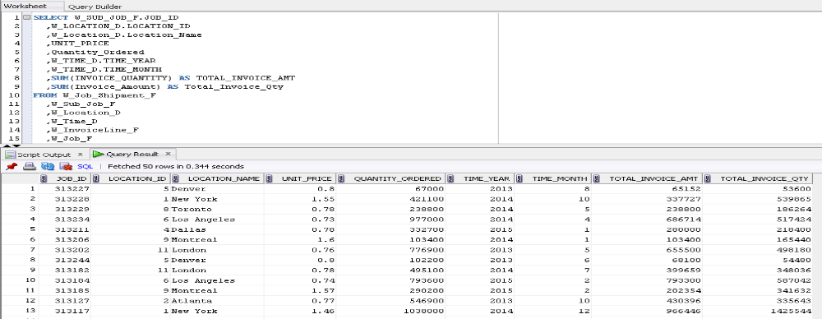

Query 3:
SELECT W_Sub_Job_F.Job_Id,
W_Location_D.LOCATION_ID ,W_LOCATION_D.LOCATION_NAME,
W_TIME_D.TIME_YEAR, W_TIME_D.TIME_MONTH,
SUM(Cost_Labor) AS SumLaborCosts,
SUM(Cost_Material) AS SumMaterialCosts,
SUM(Cost_Overhead) AS SumOvrhdCosts,
SUM(Machine_Hours * Rate_Per_Hour) AS SumMachineCosts,
SUM(Quantity_Produced) AS SumQtyProduced,
SUM(Cost_Labor + Cost_Material + Cost_Overhead +
(Machine_Hours * Rate_Per_Hour) ) AS TotalCosts,
SUM( Cost_Labor + Cost_Material + Cost_Overhead + (Machine_Hours *
Rate_Per_Hour) ) / SUM(Quantity_Produced) AS UnitCosts
FROM W_Job_F, W_Sub_Job_F, W_Location_D, W_Time_D, W_Machine_Type_D
WHERE W_Job_F.Location_Id = W_Location_D.Location_Id
AND W_Sub_Job_F.Machine_Type_Id = W_Machine_Type_D.Machine_Type_Id
AND W_Time_D.Time_Id = Contract_Date
AND W_Job_F.Job_Id = W_Sub_Job_F.Job_Id
GROUP BY W_Sub_Job_F.Job_Id, W_Location_D.LOCATION_ID,
W_LOCATION_D.LOCATION_NAME, W_TIME_D.TIME_YEAR,
W_TIME_D.TIME_MONTH;

View command:
CREATE VIEW LocCostSummary AS
SELECT W_Sub_Job_F.Job_Id,
W_Location_D.LOCATION_ID ,W_LOCATION_D.LOCATION_NAME,
W_TIME_D.TIME_YEAR, W_TIME_D.TIME_MONTH,
SUM(Cost_Labor) AS SumLaborCosts,
SUM(Cost_Material) AS SumMaterialCosts,
SUM(Cost_Overhead) AS SumOvrhdCosts,
SUM(Machine_Hours * Rate_Per_Hour) AS SumMachineCosts,
SUM(Quantity_Produced) AS SumQtyProduced,
SUM(Cost_Labor + Cost_Material + Cost_Overhead +
(Machine_Hours * Rate_Per_Hour) ) AS TotalCosts,
SUM( Cost_Labor + Cost_Material + Cost_Overhead + (Machine_Hours *
Rate_Per_Hour) ) / SUM(Quantity_Produced) AS UnitCosts
FROM W_Job_F, W_Sub_Job_F, W_Location_D, W_Time_D, W_Machine_Type_D
WHERE W_Job_F.Location_Id = W_Location_D.Location_Id
AND W_Sub_Job_F.Machine_Type_Id = W_Machine_Type_D.Machine_Type_Id
AND W_Time_D.Time_Id = Contract_Date
AND W_Job_F.Job_Id = W_Sub_Job_F.Job_Id
GROUP BY W_Sub_Job_F.Job_Id, W_Location_D.LOCATION_ID,
W_LOCATION_D.LOCATION_NAME, W_TIME_D.TIME_YEAR,
W_TIME_D.TIME_MONTH;

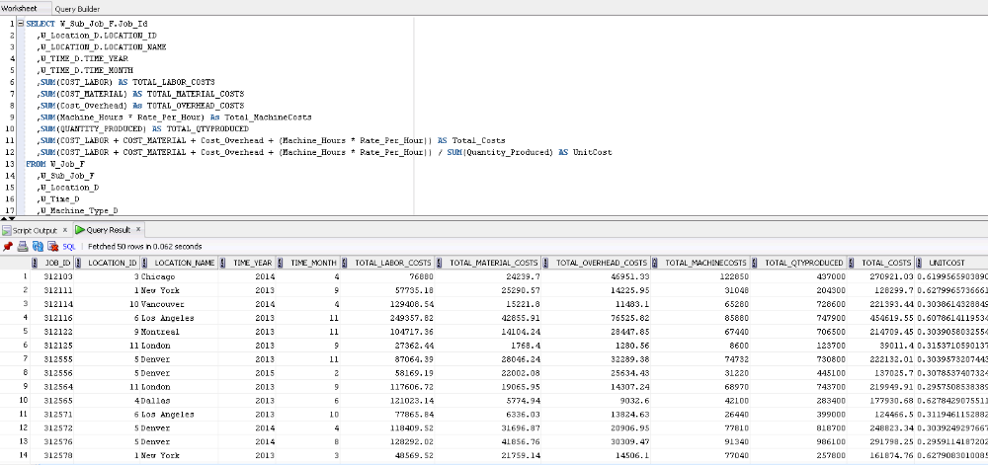

Query 4:
SELECT
W_Location_D.Location_Id, Location_Name,
W_Sales_Class_D.Sales_Class_Id, Sales_Class_Desc,
Time_Year, Time_Month,
SUM ( quantity_shipped - invoice_quantity ) as SumReturnQty,
SUM ( (quantity_shipped - invoice_quantity) *
(invoice_amount/invoice_quantity) ) AS SumReturnAmt
FROM W_INVOICELINE_F INNER JOIN W_TIME_D
ON W_INVOICELINE_F.INVOICE_SENT_DATE = W_TIME_D.TIME_ID
INNER JOIN W_Location_D
ON W_INVOICELINE_F.Location_Id = W_Location_D.Location_Id
INNER JOIN W_Sales_Class_D
ON W_INVOICELINE_F.Sales_Class_Id = W_Sales_Class_D.Sales_Class_Id
WHERE quantity_shipped > invoice_quantity
GROUP BY W_Location_D.Location_Id, Location_Name,
W_Sales_Class_D.Sales_Class_Id, Sales_Class_Desc, Time_Year, Time_Month;
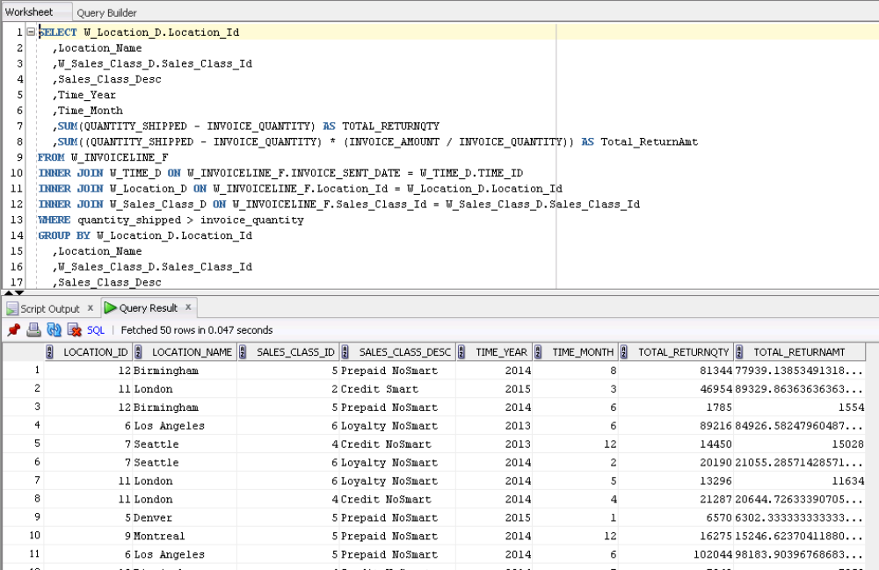

Query 5:
SELECT W_JOB_F.job_ID,
W_JOB_F.SALES_CLASS_ID, Sales_Class_Desc,
W_JOB_F.LOCATION_ID, Location_Name,
Date_Promised, Last_Shipment_Date,
QUANTITY_ORDERED, SumDelayShipQty,
GetBusDaysDiff ( date_promised, Last_Shipment_Date ) AS BusDaysDiff
FROM W_JOB_F , W_Location_D, W_Sales_Class_D,
(SELECT W_SUB_JOB_F.JOB_ID,
MAX(actual_ship_Date) AS Last_Shipment_Date,
SUM ( actual_Quantity ) AS SumDelayShipQty
FROM W_JOB_SHIPMENT_F, W_SUB_JOB_F, W_Job_F
WHERE W_SUB_JOB_F.SUB_JOB_ID = W_JOB_SHIPMENT_F.SUB_JOB_ID
AND W_Job_F.Job_Id = W_SUB_JOB_F.JOB_ID
AND Actual_Ship_Date > Date_Promised
GROUP BY W_SUB_JOB_F.JOB_ID
) X1
WHERE date_promised < X1.Last_Shipment_Date
AND W_JOB_F.JOB_ID = X1.Job_Id
AND W_Job_F.Location_Id = W_Location_D.Location_Id
AND W_Job_F.Sales_Class_Id = W_Sales_Class_D.Sales_Class_Id;

View command:
CREATE VIEW LastShipmentDelays AS
SELECT W_JOB_F.job_ID ,
W_JOB_F.SALES_CLASS_ID, Sales_Class_Desc,
W_JOB_F.LOCATION_ID, Location_Name,
Date_Promised, Last_Shipment_Date,
QUANTITY_ORDERED, SumDelayShipQty,
GetBusDaysDiff ( date_promised, Last_Shipment_Date ) AS BusDaysDiff
FROM W_JOB_F , W_Location_D, W_Sales_Class_D,
(SELECT W_SUB_JOB_F.JOB_ID,
MAX(actual_ship_Date) AS Last_Shipment_Date,
SUM ( actual_Quantity ) AS SumDelayShipQty
FROM W_JOB_SHIPMENT_F, W_SUB_JOB_F, W_Job_F
WHERE W_SUB_JOB_F.SUB_JOB_ID = W_JOB_SHIPMENT_F.SUB_JOB_ID
AND W_Job_F.Job_Id = W_SUB_JOB_F.JOB_ID
AND Actual_Ship_Date > Date_Promised
GROUP BY W_SUB_JOB_F.JOB_ID
) X1
WHERE date_promised < X1.Last_Shipment_Date
AND W_JOB_F.JOB_ID = X1.Job_Id
AND W_Job_F.Location_Id = W_Location_D.Location_Id
AND W_Job_F.Sales_Class_Id = W_Sales_Class_D.Sales_Class_Id;

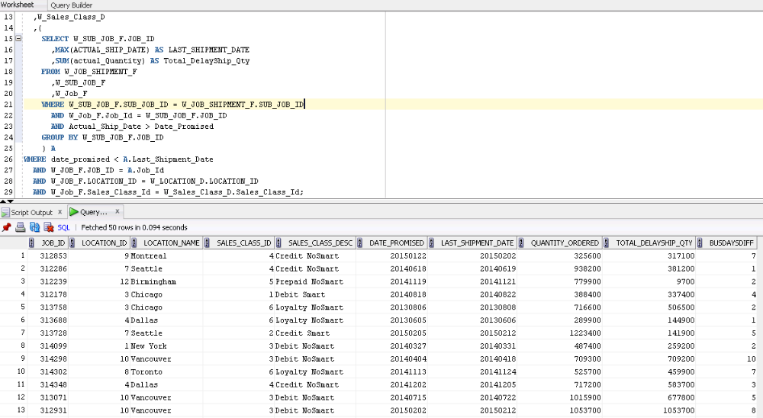

Query 6:
SELECT W_JOB_F.job_ID,
W_JOB_F.SALES_CLASS_ID, Sales_Class_Desc,
W_JOB_F.LOCATION_ID, Location_Name,
Date_Ship_By,
FirstShipDate,
GetBusDaysDiff ( date_ship_By, FirstShipDate ) AS BusDaysDiff
FROM W_JOB_F, W_Location_D, W_Sales_Class_D,
(SELECT W_SUB_JOB_F.JOB_ID, MIN(actual_ship_Date) as FirstShipDate
FROM W_JOB_SHIPMENT_F, W_SUB_JOB_F
WHERE W_SUB_JOB_F.SUB_JOB_ID = W_JOB_SHIPMENT_F.SUB_JOB_ID
GROUP BY W_SUB_JOB_F.JOB_ID
) X1
WHERE date_ship_By < X1.FirstShipDate
AND W_JOB_F.JOB_ID = X1.Job_Id
AND W_Job_F.Location_Id = W_Location_D.Location_Id
AND W_Job_F.Sales_Class_Id = W_Sales_Class_D.Sales_Class_Id;

View command:
CREATE VIEW FirstShipmentDelays AS
SELECT W_JOB_F.job_ID,
W_JOB_F.SALES_CLASS_ID, Sales_Class_Desc,
W_JOB_F.LOCATION_ID, Location_Name,
Date_Ship_By,
FirstShipDate,
GetBusDaysDiff ( date_ship_By, FirstShipDate ) AS BusDaysDiff
FROM W_JOB_F , W_Location_D, W_Sales_Class_D,
(SELECT W_SUB_JOB_F.JOB_ID, MIN(actual_ship_Date) as FirstShipDate
FROM W_JOB_SHIPMENT_F, W_SUB_JOB_F
WHERE W_SUB_JOB_F.SUB_JOB_ID = W_JOB_SHIPMENT_F.SUB_JOB_ID
GROUP BY W_SUB_JOB_F.JOB_ID
) X1
WHERE date_ship_By < X1.FirstShipDate AND W_JOB_F.JOB_ID = X1.Job_Id
AND W_Job_F.Location_Id = W_Location_D.Location_Id
AND W_Job_F.Sales_Class_Id = W_Sales_Class_D.Sales_Class_Id;

